**UNIVERSITY OF THE PUNJAB**

**BS (SE) Fall 2022 Morning**

**Web Engineering**

**Lab 1 - Introduction to C# Programming**

**Objective:**

This lab introduces you to the basics of C# programming. You will learn how to:

1. Write and display messages.
2. Read input from users.
3. Work with different data types and variables.
4. Parse string data to numeric data types.
5. Collect and display user information.

By the end of this lab, you will be able to write simple programs that handle basic input/output operations, manipulate data, and understand the core structure of a C# application.

### ****Tutorial: Create a Simple C# Console App in Visual Studio****

This tutorial walks you through the steps to create a simple C# console application using Visual Studio. Follow these steps to get started with coding your first C# program.

### ****Step 1: Create a Project****

To begin, create a new C# console application project. This project will serve as the foundation for writing your code.

1. **Open Visual Studio** and in the **Start** window, select **Create a new project**.

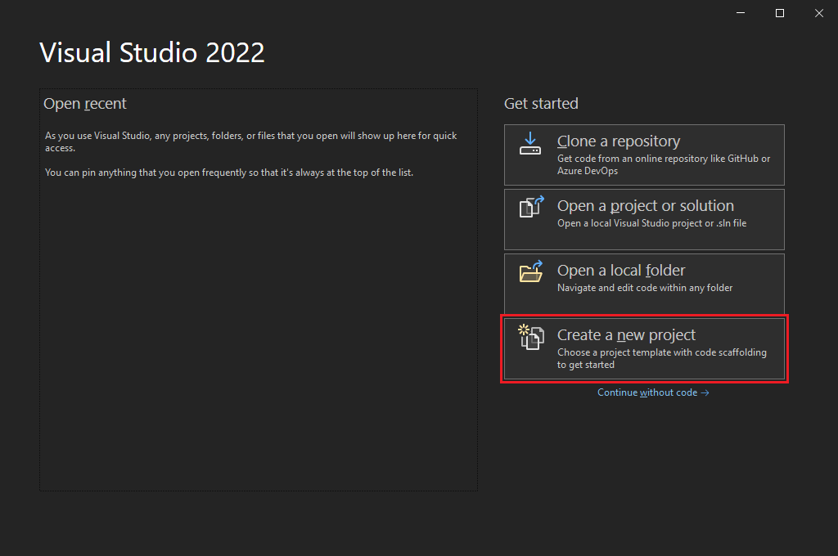

1. In the **Create a new project** window:
   * Select **All languages**, and then choose **C#** from the dropdown list.
   * Select **Windows** from the **All platforms** list.
   * Choose **Console** from the **All project types** list.
   * Select the **Console App** template, then click **Next**.

**Note:** If you do not see the **Console App** template, select **Install more tools and features**.

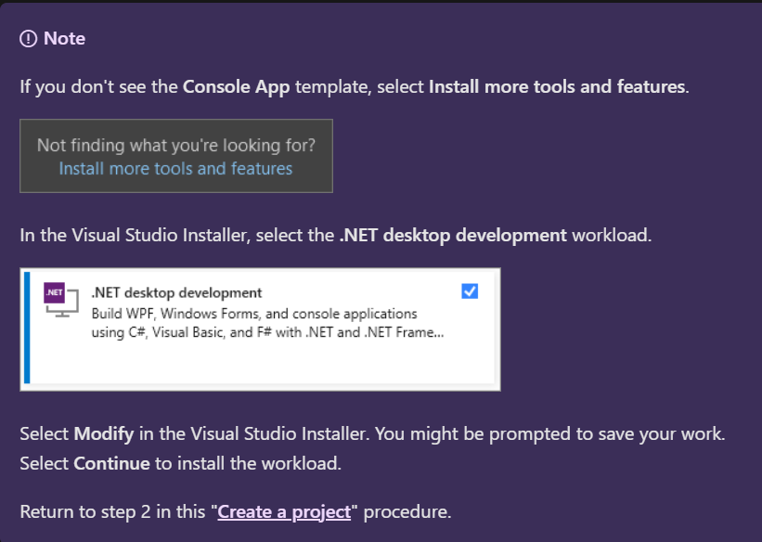

### ****Step 2: Configure Your Project****

1. In the **Configure your new project** window, enter **your project name**  as the **Project name**. Then click **Next**.

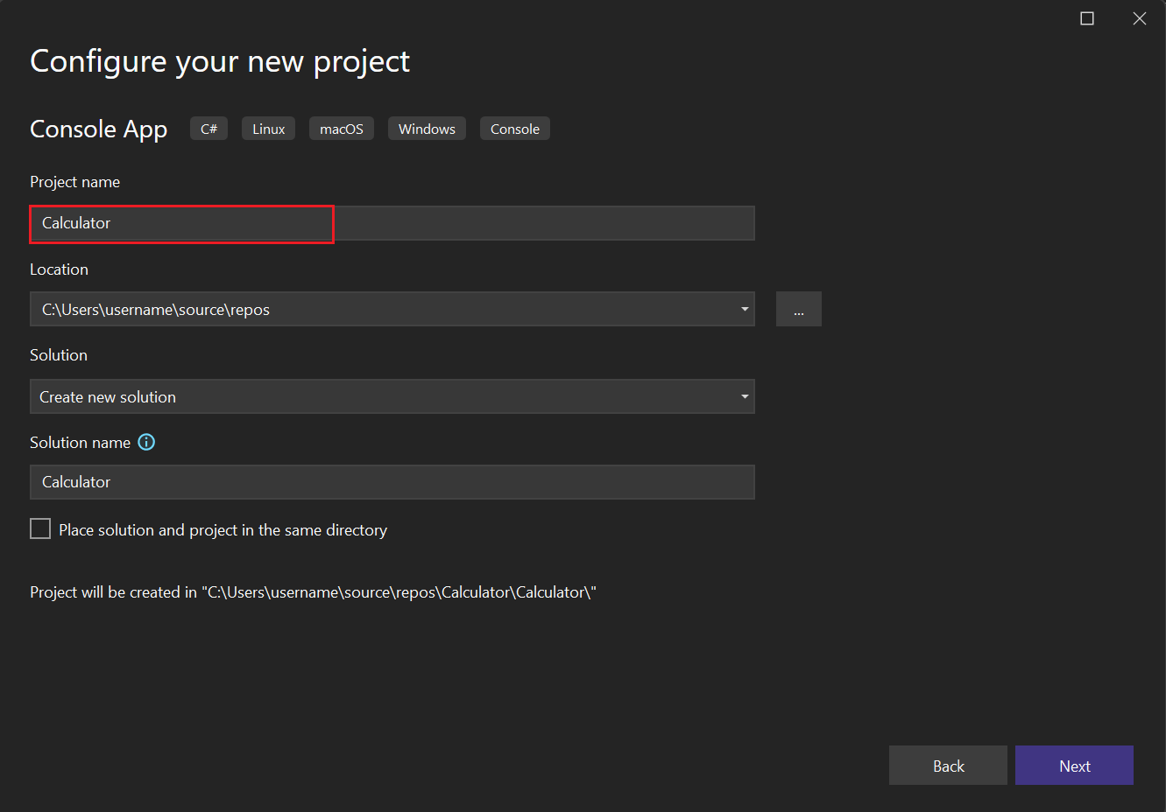

1. In the **Additional information** window, select **.NET 8.0** as the target framework. Then click **Create**.

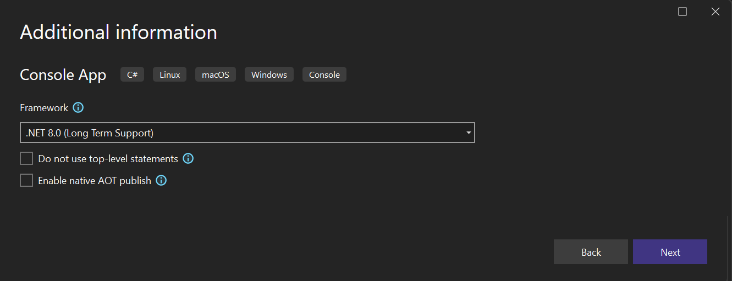

### ****Step 3: Write Your First C# Program****

Once Visual Studio creates the project, it opens your new project and includes the default "Hello World" code. Follow these steps to view and run your first program:

1. In the **Solution Explorer** window (usually on the right side of the screen), open the **Program.cs** file. You will see the following code:

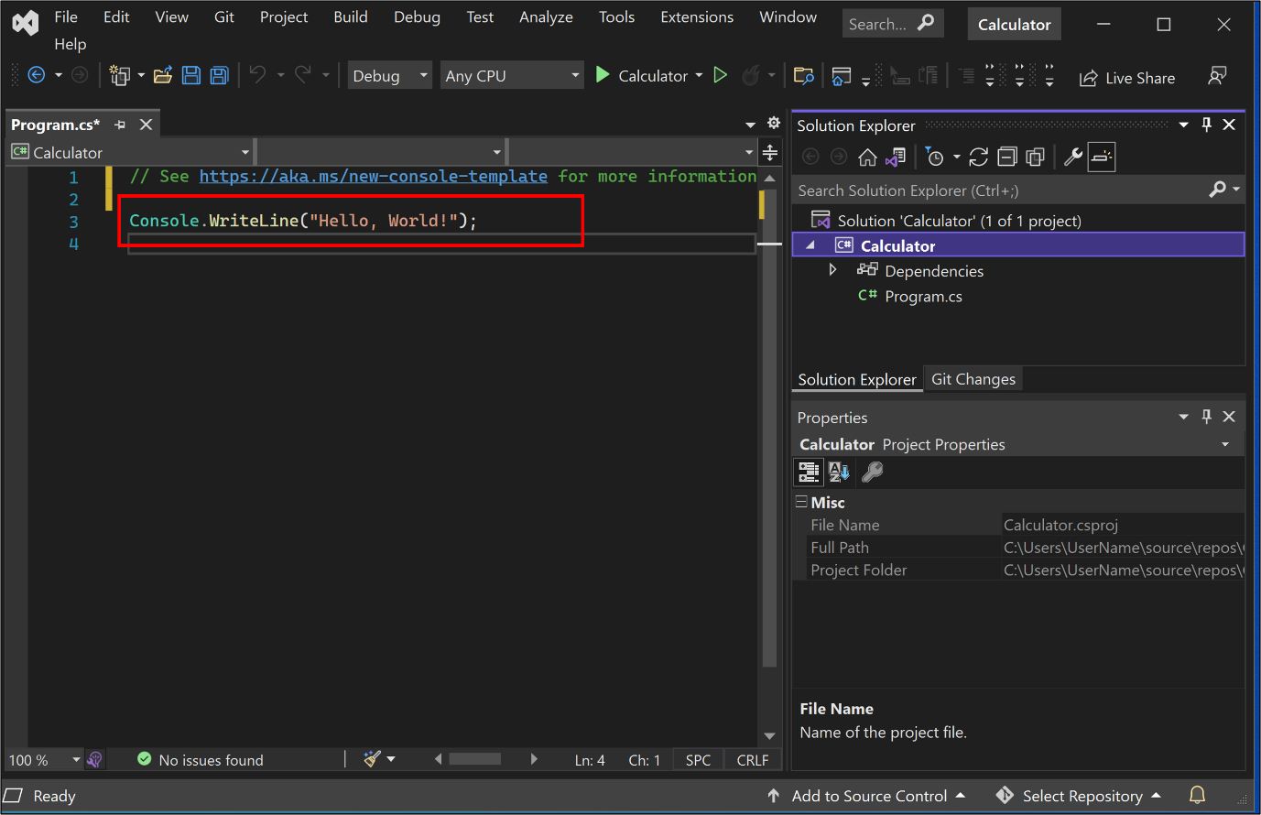

1. To build and run your app, press F5, or select the green arrow next to the name of your project in the top toolbar.

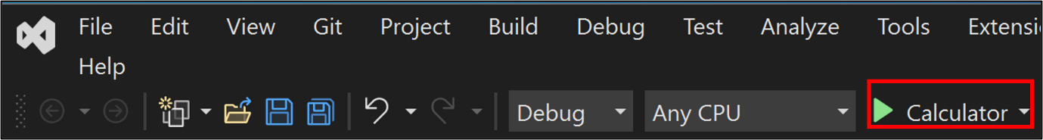

**Task 1: Taking Student Information and Displaying It**

**Instructions**:

1. Create a new **Console App** in Visual Studio.
2. Write a program that:
   * Prompts the user to enter their **name**, **age**, **course** name, and **GPA**.
   * Collects and stores the input.
   * Displays the collected information back to the user in a formatted message, e.g.,

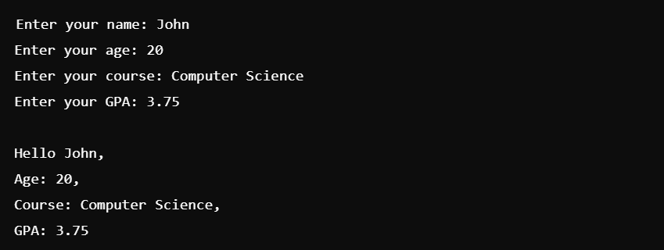

**Task 2: Data Types and Parsing**

**Instructions**:

1. Create a new **Console App** in Visual Studio.
2. Write a program that:
   * Prompts the user to enter their **birth year** as a string.
   * Converts the string input to an integer using **parsing**.
   * Calculates and displays the user's age based on the current year.
   * Additionally, ask the user for their **GPA** (entered as a string) and convert it to a **double**.
   * Display the age and GPA in a formatted message.

**Hint**: Use int.Parse and double.Parse to convert strings into integers and floating-point number and currentYear = DateTime.Now.Year

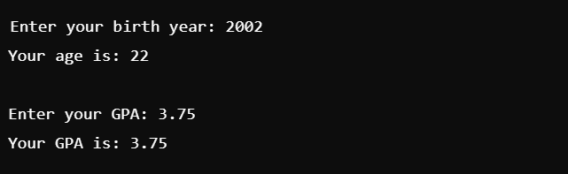

**Task 3: Predict Even or Odd**

**Instructions**:

1. Create a new **Console App** in Visual Studio.
2. Write a program that:
   * Prompts the user to enter a number.
   * Determines if the number is **even** or **odd**.
   * Displays the result in a message.
3. Use conditional logic (if-else) to implement the check for even or odd numbers.

**Hint**: An even number is divisible by 2, i.e., number % 2 == 0.

**Expected Output**:

